**o**

**Faculty of engineering - Shoubra**

**Benha University**

**Research Article / Research Project / Literature Review**

in fulfillment of the requirements of

|  |  |
| --- | --- |
| **Department** | Electrical Engineering |
| **Division** | Computer Department |
| **Academic Year** | 2019/2020- 2nd term |
| **Course name** | Electrical Power and machines |
| **Course code** | ECE381C |

**Title: -**

**DC motors and Transformers**

By:

|  |  |  |  |
| --- | --- | --- | --- |
|  | Name | Edu mail | B.N |
| 1 | Khaled Mahmoud | khaled160314@feng.bu.edu.eg | **343022** |

**Approved by:**

|  |  |
| --- | --- |
| Examiners committee | Signature |
|  |  |
|  |  |
|  |  |
|  |  |
|  |  |

**Research objectives**

Reading a Nameplate (Select Data) for a shunt DC motor.

the Equivalent circuit and the different formula for obtaining the missed data of shunt motor.

a general arrangement of the d. c. machine; showing the different parts of it and indicate the path of magnetic flux.

the performance characteristics (N/I, T/I and N/T curves of that motor.

Calculate the torque and the efficiency at full load.

Transmission systems: Types of transmission systems. Overhead and underground transmission.

Transformers: Principle of operation. E.M.F equation of a transformer. Equivalent circuit of a transformer Regulation of a transformer. Losses and efficiency of a transformer.

**Abstract**

The d.c. traction motor was used almost universally in traction drives until developments in power semiconductors made a.c. drives a practical alternative. The attraction of the dc machine for traction drives is the ease of control. In its simplest form, the controller is a manually operated rotary drum switch which progressively reduces the resistance connected in series with the machine and d.c. supply. Conversely, the developments in power converters and electronic control have produced control systems with high efficiency and wide control range incorporating several stages of automatic control.

A transformer is a device that transfers electrical energy from one circuit to another by magnetic coupling without requiring relative motion between its parts. It usually comprises two or more coupled windings, and, in most cases, a core to concentrate magnetic flux. An alternating voltage applied to one winding creates a time-varying magnetic flux in the core, which induces a voltage in the other windings. Varying the relative number of turns between primary and secondary windings determines the ratio of the input and output voltages, thus transforming the voltage by stepping it up or down between circuits. The transformer principle was demonstrated in 1831 by Faraday, though practical design did not appear until the 1880s.Within less than a decade, the transformer was instrumental during the "War of current" in seeing alternating current systems triumph over their direct current counterparts, a position in which they have remained dominant. By transforming electrical power to a high voltage, low current form and back again, the transformer greatly reduces energy losses and so enables the economic transmission of power over long distance.

**Table of contents**

|  |  |
| --- | --- |
| **Subject / section** | **Page** |
| **Introduction** | **5** |
| **Literature Review** | **6** |
| **Nameplate, equivalent circuit, and equations** | **7** |
| **Performance and construction** | **8** |
| **Ac and dc transmission** | **17** |
| **Underground, overhead transmission** | **19** |
| **Diagram and equivalent circuit for transformer** | **20** |
| **Efficiency and losses** | **22** |

**List of Figures**

|  |  |  |
| --- | --- | --- |
| **Figure I.D** | **Description** | **Page** |
| **1** | **Name plate of Shunt Dc motor** | **6** |
| **2** | **Equivalent circuit of armature** | **8** |
| **3** | **Equivalent circuit of shunt motor** | **9** |
| **4-6** | **Performance Characteristics** | **10-11** |
| **7-13** | **Each part in dc motor arrangement** | **13-15** |
| **14** | **Construction of the cable** | **17** |
| **15** | **Underground installation** | **18** |
| **16** | **Environment impact** | **19** |
| **17** | **Construction of transformer** | **19** |
| **18** | **Equivalent circuit of ideal transformer** | **21** |

**Introduction**

DC Motor is only an immediate current engine which is intended to work in direct current. Every engine is fabricated with its predetermined subtleties. The insights concerning the engine is given in the engine name plate. In this we are going to perceive how to peruse or comprehend about DC Motor through name plate subtleties.

D.C Shunt Motors: It is a constant speed motor. Where the speed is required to remain almost constant from no-load to full load. Where the load must be driven at a few speeds and any. One of the main advantages of a.c. transmission and distribution is the ease with which an alternating voltage can be increased or reduced. For instance, the general practice is to generate at voltages about 22 kV, then step up by means of transformers to higher voltages for the transmission lines. At suitable points, other transformers are introduced to step the voltage down to values suitable for motors, lamps, heaters, etc. A medium-sized transformer has a full-load efficiency of about 97–98 per cent, so that the loss at each point of transformation is small (although 2 per cent of 100 MW is not insignificant!). Since there are no moving parts in a transformer, the amount of supervision is practically negligible. Although transformers are generally associated with power system applications, they also occur in many low-power applications including electronic circuits. However, it is best to first consider the common power-system transformer. The common form of transformer involves a ferromagnetic core in order to ensure high values of magnetic flux linkage. This is also true of the rotating machines which we shall meet in the following chapters. There are factors about the ferromagnetic core which affect the construction of transformers and rotating machines; these factors are responsible for part of the loss associated with power transfer and require a brief explanation before considering the principle of action of a transformer.

**Literature Review**

Figure Nameplate of shunt dc motor

**Make: CG.** The Motor is manufactured by Crompton Greaves. In such way, you can see some other motor manufactured such as Siemens, ABB, IEC, Kirloskar, BHEL etc. **M/C Number: SALG859.** In this, you can find the machine model number. Each machine has its separate model. Machine number of DC motor tells about the design details. **REF: MBAD 0016** This is for manufacture reference purpose. This number is used to find out the testing details. Also, this is the reference number for feature spare procurement for the same motor. **kW: 3.7** The Maximum force that can be provided by the engine. Likewise, it says about the engine vitality utilization. In this, the DC engine can devour just 3.7 unit every hour at 100% burden (full burden current).**Frame size: ASHC 132L** Here 132L means the height of the motor from footer to shaft center is 132 mm and L means the core size is length. In such way that you can find some other core size medium ‘M’ and Short for ‘S’ **RPM: 1500** This is

the speed of the DC motor. The motor rotates at 1500 revolution per minutes. Also, you can vary the speed of the DC Motor by changing the armature voltage and field current. **Insulation class: F** Insulation class mentions that the type of insulation material is used in the motor winding. This is an important data, to control the body temperature of the motor. The motor can withstand at maximum temperature of 155deg. Each insulation class have its own temperature withstanding. Here you can find that the temperature class. **Excitation: SEP** In this, we can come know what type of excitation system used for exciting field winding. Here SEP means separately excited, also SELF means self-excited DC motor. For SEP type motor we must give separate DC power supply to the motor. **Armature Voltage: 110 Volts** The rated armature voltage is 110 DC volts. More than 110 volts supply to the armature winding is not recommended. **Duty: S1** Duty is nothing but the operating hours of the DC motor. In this, S1 duty means we can run the motor for 365 days X 24 hours. here you can find the other motor duty operation. **Type: SHUNT** It tells about the field coil position. Three types of DC motors are most popular. First one is Series motor, second one is shunt motors and compound motor. In this our motor field coil is connected in parallel with the armature winding. **Armature current: 40 Amps** The rated current of the armature is 40 Amps. This is full load capacity of the motor. Also, we can load any motor at 120% of the full load. **MTG: B3** MTG B3 means the mounting of the motor. B3 means foot mounting. The motor operates in the bed. Some other types of mountings are flange mounting and foot come flange mounting is available in the market. Mounting is depending upon the application only. Before purchasing a motor, you should clearly mention the type of mounting. **Bearing CE: 6206 2RS & Bearing NCE 6309 2RS** It is same as induction motor DE & NDE. Here CE means commutator end. The commutator side motor bearing number is 6206 2RS. Non-Commutator end side bearing number is 6306 2RS. This data is used for spare bearing procurement process. **Field Voltage: 110 Volts. & Field Current: 0.87 Amps**

The input DC voltage of filed winding is 110 Volts. & the Maximum rated current of the field winding is 0.87 amps. **AMB 50 deg:** It means the ambient temperature of the motor is 50 deg. The motor can operate with the surrounding temperature of 50 deg.

**Protection: IP55** Protection from dirt, dust, oil, and other non-corrosive material

**Cooling IC 0041:** The fan cooled motor which cools the stator as well as rotor of the machine. The cooled air is pushed through the armature air gap using fans.

Equivalent Circuit of a DC Motor Armature :

Figure equivalent circuit of a DC Motor armature.

In a DC motor, the current flows from the line into the armature, against the generated voltage.by applying KVL.

V = Eb + Ia Ra or V = Eb + IaRa + Vb <<fundamental motor equation>> where, V- Motor terminal voltage, Eb- Back EMF, Ia- Armature current, Ra- Armature circuit resistance,

Shunt Wound Motor This is the most common types of DC Motor. Here the field winding is connected in parallel with the armature.

Figure shunt wound motor connects parallel with the armature.

By applying KCL at junction A,

I = Ia + Ish , where I- input current, Ia- armature current, Ish- the shunt field current.

V = IshRsh , for armature V = E + IaRa.

Power equation is given as

**Power input = mechanical power developed + losses in the armature + losses in field.**

**VI = Pm + I­2aRa + I2sh Rsh**

**VI =­ Pm + I­2aRa + VIsh**

**Pm = VIa - I­2aRa  = EIa.**

From V = E + IaRa. multiply be Ia,

VIa = Ela + **I­2aRa.**

VIa = Pm + **I­2aRa.**

**1-Torque- Armature Current (T-Ia)characteristics :**

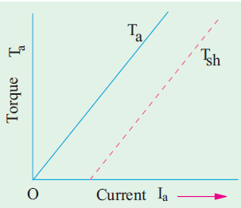If the applied voltage is kept constant the field flux remains constant. The torque of the DC motor is proportional to the product of the flux and the armature current.  
Ta 𝝰 Φ Ia  
Ta 𝝰 Ia  ( Φ constant)  
The characteristic of torque and armature current is a

Figure electrical characteristics Ta/Ia characteristics.

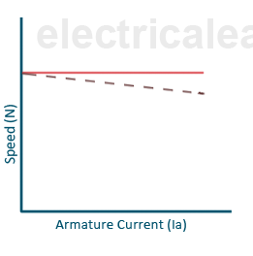straight line from the origin. The shaft torque is always less than the gross torque. This is because of stray losses.The heavy starting loads require more armature current, so shunt motor should not be started on heavy loads.

Figure speed armature current characteristics

**2- Speed- Armature Current(N-Ia) characteristics :**

The speed of the motor is directly proportional to the back EMF(Eb) and reciprocal to the flux.  
N α Eb / Ф f  
The back EMF(Eb)= V- Ia.Ra

With an increase in the armature current with a load, the back EMF decrease very small due to small IaRa voltage drop as armature resistance is very low.

The flux also decreases with an increase in load current due to the armature reaction. Thus, the ratio of Eb/Φ remains almost constant, and the speed of the motor is almost constant with an increase of armature current with loading.

The actual speed represented by the dotted line; Therefore, the DC shunt motor is a constant speed motor.

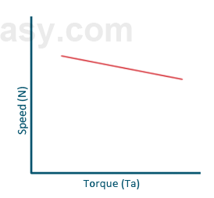

Figure speed-torque characteristics.

**3-Speed-Torque(N-T) characteristics :**

The change in the speed does not matter torque.

**Torque** is the twisting moment of a force about axis. Measured by product the force and the radius at which this force acts.

T = F × r (newton – meter)

In one revolution

T = F × 2 PI r (Joul)

Power developed = F × 2 PI r × N (watt)

= ( F × r ) × (2 PI N) (watt), 2PIN is w angular velocity

P = T × w , so T = P / W and if it in r.m.p,

P = (2PIN / 60 ) × T = (NT) / (9.55).

P = Eb Ia, Ta = 9.55 ( N-m.

Efficiency = Po/p  / Pi/p , Pi/p = Vt It.

The construction of a DC Shunt Motor is the same as any other DC motor. It contains all the fundamental parts, which include a stator (field windings), a rotor (also known as armature), and a commutator.

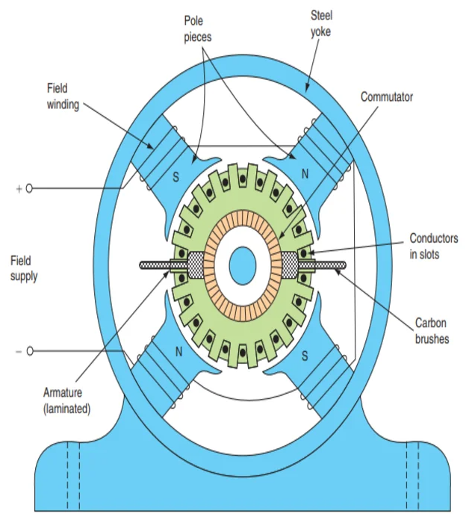

Figure DC motor with plan cutting.

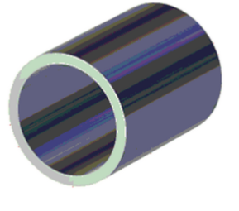1- The yoke of DC motor: The yoke is the outer cover (frame) of the machine, it’s made of [cast iron](https://en.wikipedia.org/wiki/Cast_iron) in small machines where cheapness is an important consideration and in large machines, it’s made of cast, silicon, or rolled steel to provide high permeability.

Figure Yoke

It has the importance that it: Provides a mechanical support to poles. Provide protection from dust, moisture, and various gases to the whole machine. Carries the magnetic flux produced by the poles.

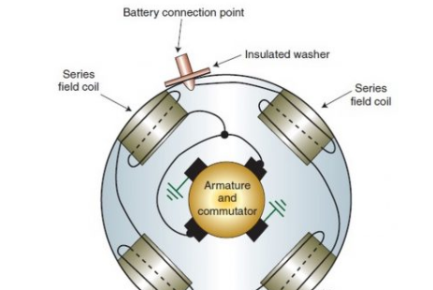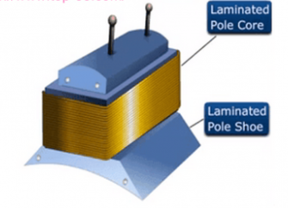2-Pole shoes and pole core of DC Motor: Pole core is a solid piece made of cast iron or cast steel build of thin laminations which are perfect to reduce [power losses due to eddy current](https://www.top-ee.com/losses-in-transformer/), the function of these poles is: Provide magnetic flux when the field winding in excitation case. Directs the flux produced through the air gap to armature core to the next pole.

Figure Pole shoes and pole core

3- field winding of DC Motor: it is usually copper conductor wound around pole core with a definite direction, we usually connect It in series when current passes through produce necessary flux.

Figure Field winding

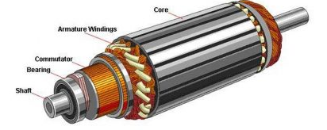4-Armature core of DC Motor: cylinder shape mounted to the shaft between poles and keyed to the machine shaft it uses high permeability lower reluctance materials provides path for flux produced by the field winding.

Figure armature

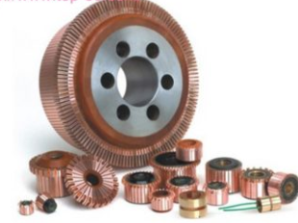5- Commutator of DC Motor: the commutator is a cylindrical mechanical rectifier made of edge shaped copper segments insulated from each other it converts ac current or voltage produced in armature to direct current or voltage with help of brushes. 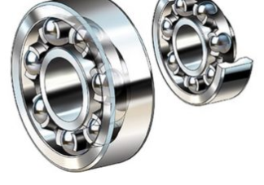

Figure Commutator

6- Bearings most popular because they are more reliable, so they are the perfect on heavy duty machines.

Figure bearings

**Types of transmission systems,** DC transmission system and Ac transmission system.

**The advantages of DC transmission system are**

1-Only two conductors are used for transmission compound with 3 conductors in AC system causing much saving in copper.

2- The potential stress produced on the insulation by the DC system is approximately 70% of the AC effective voltage of same value.

3-Inductance, capacitance, phase displacement and swage problems are eliminated in DC transmission.

4- No Stability are required when transmitting over longer distance

5- the economical of underground cables possible, since the stress on cable insulation is much less,

**The advantages of AC transmission are**

1-It is possible to generate high voltage compound to dc system.

2-The ac voltages can efficiently be stepped up by transformers which is not possible in DC system.

3- the lowering of the voltage ate the substation is easier and cheaper as compared to DC system ( using motor, generator sets or rectifiers).

4-The transforming sub-station are much efficient than the motor generator sets used in DC system.

5-The maintenance of AC sub-station is easier and is cheaper

**The disadvantages of AC transmission are**

1-The volume of copper used is much more than the DC system.

2-the inductance and capacitance of the line effects the regulation of the line which is increased.

3-Due to skin effect the line resistance is increased which further increases the skin effect.

4-The AC transmission line are more effective to corona than the DC lines

5-In cables the AC current causes sheath loss.

6-the alternates must be synchronized before they are made to sun in parallel.

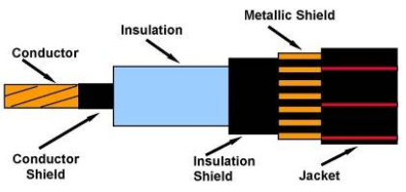**The underground and overhead transmission.**

Figure a construction of cables

**Construction**

The underground links are increasingly costly to develop and introduce, nonetheless, they are helpful, more averse to break and for the most part used to give the missing connection where overhead links can't be utilized. The decision of the link to utilize is dictated by the specific circumstance. The overhead links are broadly utilized because of their expense and capacity to convey more force contrasted with the underground.

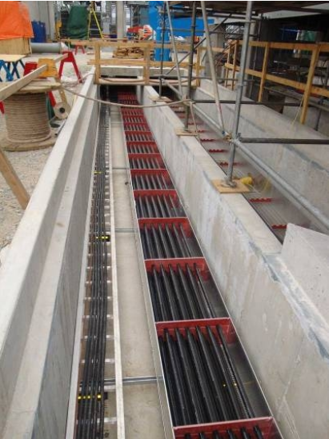**Installation** The installation of overhead lines on poles is easier and straightforward. However, the underground cables require digging trenches and this may be complicated by other utility service lines such as water pipes, oil and gas pipelines, sewer lines. Other complications may arise due to rocks, loose soil and water along the routes, making them more expensive to install.

Figure installing underground cobles

**Heat dissipation** Heat dissipation in underground cables is limited by the layers of insulation and protection such as armoring and sheaths. Most of the heat is therefore retained near the cable unlike the overhead cables where most of the heat is released to the surrounding and automatic natural cooling is provided by the air

**Size of Conductors** Underground cables have larger conductor sizes compared to overhead lines for the same amount of power. This is since the overhead lines have a natural cooling and hence the ability to carry more power without heating up.

**Voltage carrying capacity** the overhead lines are better suited to carry higher voltages compared to the underground cables, which are limited by the expensive construction and limited heat dissipation. For these reasons, the underground cables are mostly used for transmitting up to 33KV.

**Fault detection and repair** It is easier to detect and repair faults in overhead cables. It is more complicated and takes more time to locate and repair the underground systems.

**Public safety** underground cables are safer to the public, animals and environment compared to the overhead lines i.e. there are no issues such as people getting in contact with fallen lines. The overhead cables can be brought down and human, animal intervention, weather as well vegetation such as trees. The underground cables are less impacted by these conditions and not affected by trees, animals, accidents, wind, storms and other physical interference that may lead to broken poles and short circuits or cable breakages.

### **Effect of lightning discharges** Overhead cables are more prone to lightning strikes whereas the underground cables are not affected by the discharges.

### **Interference** Overhead lines interfere with communication lines that are in proximity, have corona discharge, radio and TV interference which does not happen with the underground lines.

### **Voltage drops**

There is more voltage drop in the overheads since their cables are of much smaller diameter than underground cables for the same power delivery.

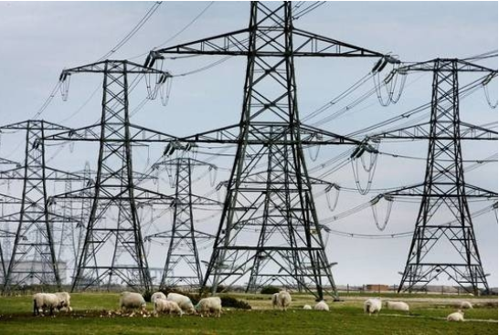**Environmental impact** the underground cables have more environmental and health benefits due reduced noise and better vegetation management. In addition, they have less transmission losses, reduced damage and accidents such as wildlife electrocutions. On the other hand, the overhead cables can be brought down by human, animal intervention, weather such as strong winds and storms, as well vegetation such as tall trees. The underground cables are less impacted by these conditions and have less visual impact.

Figure overhead and environmental impact.

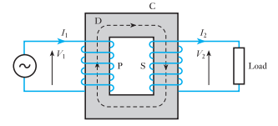**Principle of operation of a transformer**

Figure a diagram for transformer with primary and secondary coils.

A steel core C consists of laminated sheets, the purpose of laminating the core is to reduce the eddy-current loss.

The vertical portions of the core are referred to as *limbs* and the top and bottom portions are the *yokes*.

Coils P and S are wound on the limbs. Coil P is connected to the supply and is therefore termed the *primary*; coil S is connected to the load and is termed the *secondary*.

An alternating voltage applied to P circulates an alternating current through P and this current produces an alternating flux in the steel core, the mean path of this flux being represented by the dotted line D. If the whole of the flux produced by P passes

through S, the E.M.F. induced in each turn is the same for P and S. Hence, if *N*1 and *N*2 are the number of turns on P and S respectively,

= =

When the secondary is on open circuit, its terminal voltage is the same as the induced EMF. The primary current is then very small, so that the applied voltage *V*1 is practically equal and opposite to the EMF induced in P. Hence:

= =

Since the full-load efficiency of a transformer is nearly 100 per cent,

I1 . V1 . primary power factor = I­­2 . V2 . secondary power factor, factors at full load nearly equal.

When the secondary in on open circuit the primary current produce the flux necessary to induce emf that is practically equal and opposite to applied voltage.

When a load connected across the secondary terminals, the secondary current produces a demagnetizing effect by Lenz’s law. The flux and the emf induced in the primary are reduced slightly. But that small change able to increase the difference between applied voltage and the emf induced in the primary.

magnetic flux forms the connecting link between the primary and secondary circuits and that any variation of the secondary current is accompanied by a small variation of the flux and therefore of the emf induced in the primary, thereby enabling the primary current to vary approximately proportionally to the secondary current.

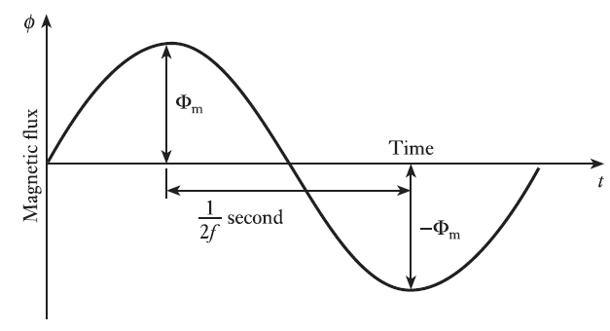

**EMF Equation of a Transformer**

Average rate of change of flux = 4ƒ Φm weber per seconds,

RMS value of emf induced per turn = 1.11 × 4ƒ Φm

Hence r.m.s. value of e.m.f. induced in primary is

E1 = 4.44 N1 ƒ Φm  volts

Hence r.m.s. value of e.m.f. induced in secondary is

E2 = 4.44 N2 ƒ Φm  volts

If Ø = instantaneous value of flux in weber = Φm sin(2 ƒ t),

dØ/dt = 2ƒΦm cos(2ƒt) volts

dØ/dt = 2ƒΦm sin(2ƒt +/2 ) volts

maximum value of induced emf per turn = 2ƒΦm volts and rms value of induced emf per turn is qual 4.44 ƒΦm volts.

**Equivalent circuit of a transformer**

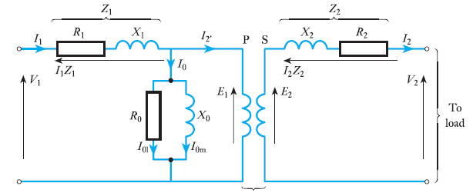the actual transformer by means of additional circuits or impedances inserted between the supply and the primary winding and between the secondary and the load. P and S represent the primary and secondary winding of ideal transformer, R1 and R2 are resistance equal to the resistances of the primary and secondary windings of the actual transformer.

Figure equivalent circuit for ideal rransformer.

inductive reactance’s *X*1 and *X*2 represent the reactance’s of the windings due to leakage flux in the actual transformer.

**Voltage regulation of a transformer**

The voltage regulation of a transformer is defined as the variation of the secondary

voltage between no load and full load, expressed as either a per-unit or a percentage of the *no-load* voltage.

Voltage regulation =

If V1 applied voltage

Second voltage on no load = V1 ×

Primary voltage drop is negligible due to no-load current.

If V2 secondary terminal voltage on full load,

Voltage regulation =

= per unit.

= 100 per cent.

**Losses and Efficiency of a transformer**

The losses which occur in a transformer on load can be divided into two

groups:

1. *I*2 *R* losses in primary and secondary windings, namely I22 *R*1 + *I­­­*22 *R*2.

2. Core losses due to hysteresis and eddy currents. The factors determining

Since the maximum value of the flux in a normal transformer does not vary by more than about 2 per cent between no load and full load, it is usual

to assume the core loss constant at all loads.

Hence, if *P*c = total core loss, total losses in transformer are

*P*c + I22 *R*1 + *I­­­*22 *R*2.

Efficiency = =

=

η = 1 -

**Results and discussion**

The underground links are increasingly costly to develop and introduce, nonetheless, they are helpful, more averse to break and for the most part used to give the missing connection where overhead links can't be utilized. The decision of the link to utilize is dictated by the specific circumstance. The overhead links are broadly utilized because of their expense and capacity to convey more force contrasted with the underground.

One of the most important and ubiquitous electrical machines is the transformer. It receives power at one voltage and delivers it at another. This conversion aids the efficient long-distance transmission of electrical power from generating stations. Since power lines incur significant *I*2*R* losses, it is important to minimize these losses by the use of high voltages. The same power can be delivered by high-voltage circuits at a fraction of the current required for low-voltage circuits. In this chapter, the design of the magnetic circuit, the core of the transformer, will first be considered. Thereafter, the principle of transformer action is introduced and developed by consideration of the transformer’s phasor diagram. The significance of the no-load behavior of the transformer is explained and of the magnetizing

The transformer equivalent circuit is a powerful analytical tool which facilitates an understanding of the behavior of the transformer on load and of the losses which occur in the transformer windings. The losses cause the ratio of input to output voltage to vary – they usually cause the output voltage to fall but it can, under certain circumstances, rise. The important concepts of voltage regulation and efficiency are developed. Finally, a variety of specialist transformers, the current transformer, the auto transformer and the air-cored transformer, are introduced.

**Conclusions**

The current get through a conductor cause magnetic field determined by hand rule and direction and magnitude from Faraday’s law, mean while the construction of the dc motor should be pandemic and equilibrium between speed and fraction and the torque of the armature is so important to know and the construction is needed to be more important to be known and less cheaper and more reliable to get read the data out of the shield.

The underground cables are more expensive to construct and install, however, they are convenient, less likely to break and mostly used to provide the missing link where overhead cables cannot be used. The choice of the cable to use is determined by the situation. The overhead cables are widely used due to their cost and ability to carry more power compared to the underground.

**References**

[1] Electric Motors and Drives: Fundamentals, Types and Applications Textbook by Austin Hughes.

[2] Direct Current Machines Mohsen Z.El-Sherif

[3] Electric Motor Control: DC, AC, and BLDC Motors Book by Sang-Hoon Kim

[4] K. P. Puchlowski, "Electronic control of D-C motors," in Electrical Engineering

[5] ELECTRICAL AND ELECTRONIC TECHNOLOGY tenth edition EDWARD

Revised by John Hiley, Keith Brown and Ian McKenzie Smith

[6] websites [www.ieee.org, www.ekb.eg, dl.acm.org]